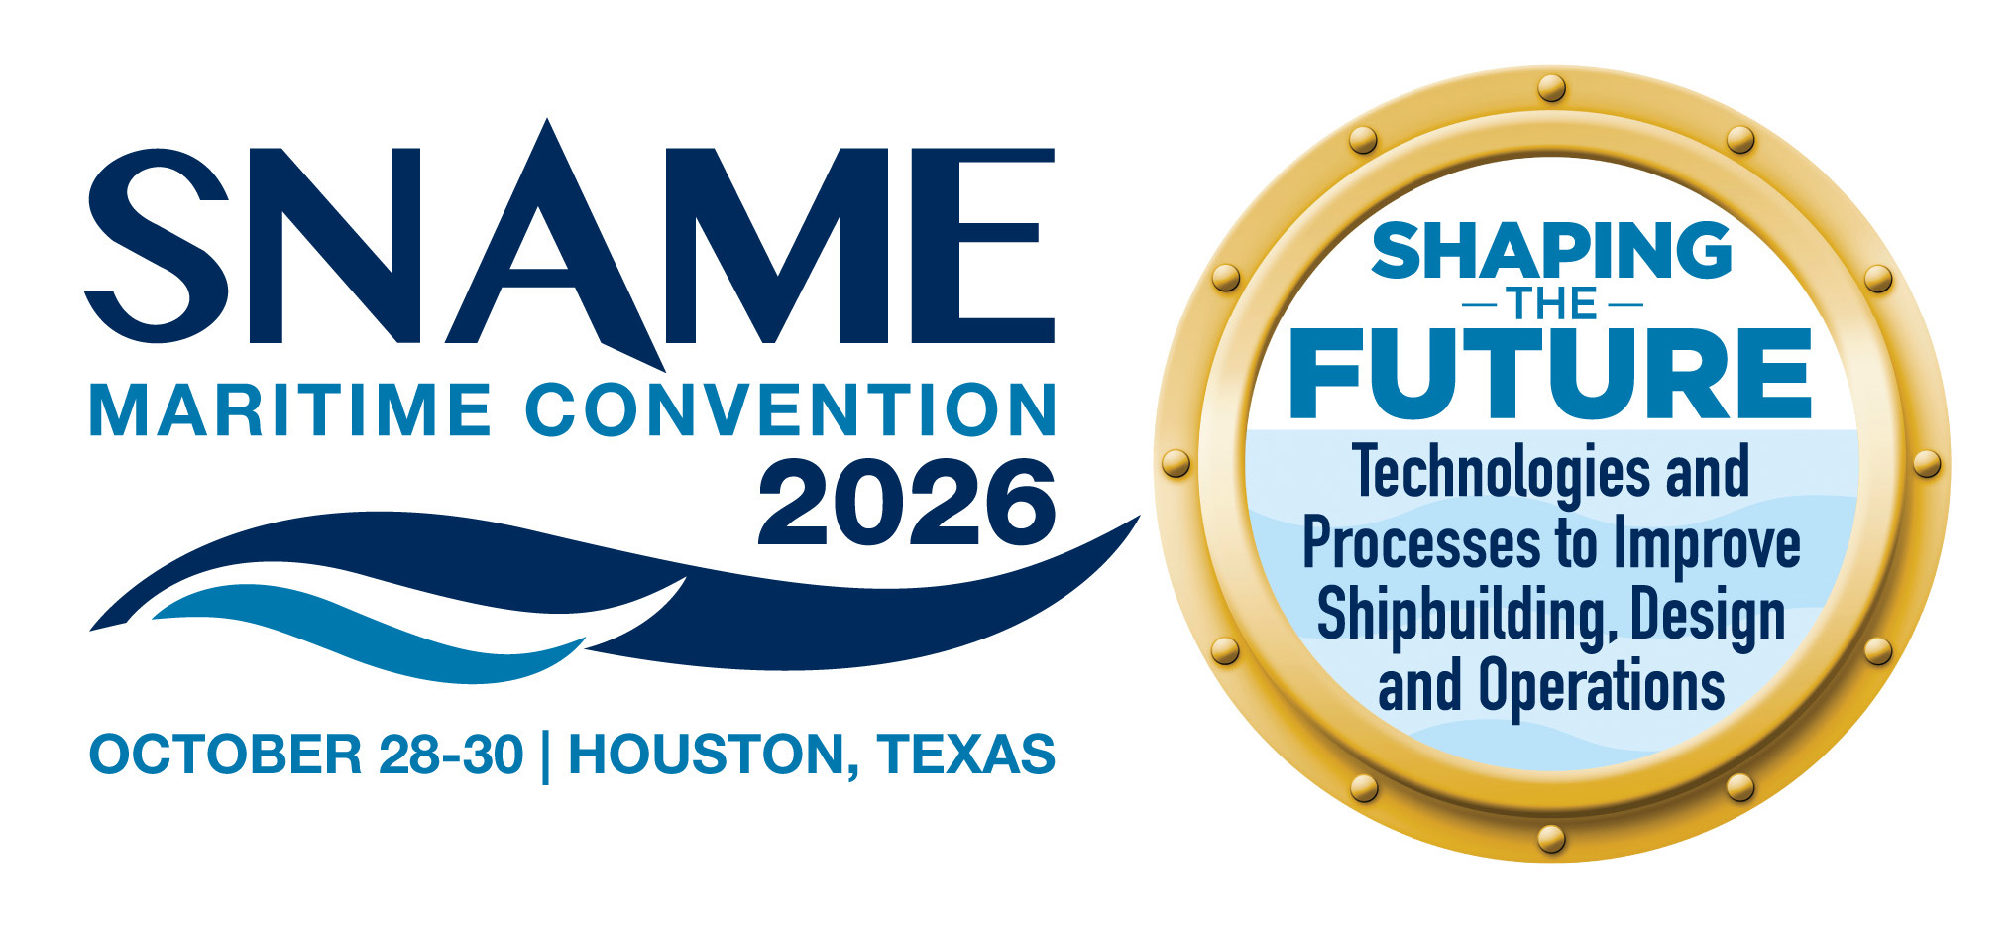

Thursday, October 29, 2026
TIME | PROGRAM | Location
7:00 AM – 24 HH | Office | Directors
7:00 AM – 7:00 PM | Registration OPEN
7:30 AM – 10:00 AM | Breakfast & Panel  Breakfast Sponsored by: | Discovery
7:45 AM – 8:00 AM  (15 Minutes) | Welcome Remarks | Discovery
8:00 AM – 10:00 AM  (120 Minutes) | PANEL Session 1 (Keynote Panel/CEOs)  US Shipbuilding: Identifying Levers for Success  Speakers:  Moderator: Peter Wallace  Panel Sponsored by: | Discovery
10:00 AM – 5:30 PM | Exhibit Hall Open | Legends Ballroom
 | TECHNICAL SESSION 1
10:10 AM – 11:00 AM  (50 Minutes) | Tech Session 1A (SMC-024) TRACK: Hydrodynamics  Hydrodynamic Loads Comparison Between Two Model Scales in Hydroelastic Experiments  Speaker: Cora Scolaro; Raju Datla; Ahmed M. Ibrahim; Karl Stambaugh  Moderator: | Founders I
10:10 AM – 11:00 AM  (50 Minutes) | Tech Session 1B (SMC-017) TRACK: Design  System-Level Evaluation of Sustainable Energy Pathways for Marine Propulsion  Speaker: Hendrik Fokko van Hemmen; Ioannis Chalaris  Moderator: | Founders II
10:10 AM – 11:00 AM  (50 Minutes) | Tech Session 1C (SMC-073) TRACK: Production  Launching The Canadian Joint Support Ship: Analysis, Planning & Execution  Speaker: Matthew Hayne; Bechir Marouani  Moderator: | Founders III
10:10 AM – 11:00 AM  (50 Minutes) | Tech Session 1D (SMC-007) TRACK: Structures  Corrosion Tests of Multiple 3D-printed of Small-scale Ship Propellers  Speaker: Vincent Xiaochuan Yu; Savannah Spivey; Erica Murray  Moderator: | Founders IV
11:00 AM – 11:30 AM | Break / Visit Exhibits  Sponsored by:
 | TECHNICAL SESSION 2
11:30 AM – 12:20 PM  (50 Minutes) | Tech Session 2A (SMC-018) TRACK: Hydrodynamics  Coupled Structural–Fluid Dynamics Model Using the Absolute Nodal Coordinate Formulation for Flexible Line Structures  Speaker: Motoki Araki  Moderator: | Founders I
11:30 AM – 12:20 PM  (50 Minutes) | Tech Session 2B (SMC-025) TRACK: Design  Observation-Based Sea State Tables for use in Design  Speakers: Sean Kery  Moderator: | Founders II
11:30 AM – 12:20 PM  (50 Minutes) | Tech Session 2C (SMC-060) TRACK: Production  When Batteries Become Infrastructure: Installation and Commissioning Challenges of Large-Scale Marine Energy Storage Systems  Speakers: Irwan Kwik  Moderator: | Founders III
11:30 AM – 12:20 PM  (50 Minutes) | Tech Session 2D (SMC-039) TRACK: Structures  Towards the Next Generation of Models for Hydroelastic Experiments  Speakers: Ahmed M. Ibrahim; Michael Czabaj; Jonathan Slager  Moderator: | Founders IV
12:20 PM – 1:30 PM | Lunch / Visit Exhibits  Overflow Seating in Discovery Ballroom  Sponsored by: | Legends Ballroom
1:30 PM – 3:20 PM  (110 Minutes) | PANEL Session 2  Current and Future Development of the US Maritime Sector  Speakers: Bradley Golden, Anthony Nygro, James Maloney  Moderator: Hariharan Balasubramanian  Sponsored by: | Discovery
1:30 PM – 3:20 PM | Student Industry Round Table | Champions III
 | TECHNICAL SESSION 3
1:30 PM – 2:20 PM  (50 Minutes) | Tech Session 3A (SMC-058) TRACK: Hydrodynamics  Stepped Planning Hulls: A Comprehensive Review of Current Knowledge, Design Practices, and Research Gaps  Speaker: Jaye Falls; Carolyn Judge  Moderator: | Founders I
1:30 PM – 2:20 PM  (50 Minutes) | Tech Session 3B (SMC-042) TRACK: Design  From Shipyard to Sea: Designing Marine Engineering Systems for Maintainability  Speaker: Susan Noste  Moderator: | Founders II
1:30 PM – 2:20 PM  (50 Minutes) | Tech Session 3C (SMC-XXX) TRACK:  Course Title  Speaker:  Moderator: | Founders III
1:30 PM – 2:20 PM  (50 Minutes) | Tech Session 3D (SMC-064) TRACK: Operations  Development and Testing Efforts for a US Coast Guard Product Lifecycle Management System  Speaker: Patrick D. Roberts; John P. Walk; CAPT Emily L. Tharp; Ryan Roberts  Moderator: | Founders IV
 | TECHNICAL SESSION 4
2:30 pm – 3:20 pm  (50 Minutes) | Tech Session 4A (SMC-004) TRACK: Hydrodynamics  A Comparison of Wakesurfing, Wakeboarding and Waterskiing Wake Characteristics  Gregor John Macfarlane  Moderator: | Founders I
2:30 pm – 3:20 pm  (50 Minutes) | Tech Session 4B (SMC-104) TRACK: Design  Design and Assurance Considerations of a Nuclear Power System for a Merchant Vessel  Speakers: Peter Wallace  Moderator: | Founders II
2:30 pm – 3:20 pm  (50 Minutes) | Tech Session 4C (SMC-083) TRACK: Production  Digital Twin-based Scheduling System for Large-scale Ship Block Assembly  Speakers: Won Seok Choi; Kanika Singh; Jong Hun Woo  Moderator: | Founders III
2:30 pm – 3:20 pm  (50 Minutes) | Tech Session 4D (SMC-XXX) TRACK:  Course Title  Speakers:  Moderator: | Founders IV
3:20 PM – 3:50 PM | Break / Visit Exhibits  Sponsored by: | Legends
3:50 PM – 4:40 PM  (110 Minutes) | PANEL Session 3  Early Stage Design Maneuvering Prediction Panel Reprise "Stump the Chumps”  Speakers: Frans Quadvlieg, Rick Ashcroft  Moderator: Adrian Onas  Sponsored by: | Discovery
 | TECHNICAL SESSION 5
3:50 PM – 4:40 PM  (50 Minutes) | Tech Session 5A (SMC-061) TRACK: Hydrodynamics  Resistance Assessment of a Series 58 Submarine Model used in Innovative Drag Reduction Study  Speaker: Matthew Coogan; Elliot Ocheltree; Adrian Sorin Onas  Moderator: | Founders I
3:50 PM – 4:40 PM  (50 Minutes) | Tech Session 5B (SMC-013) TRACK: Design  A Methodology for Evaluating Alternative Fuel Tank Sizing and Tradeoffs  Speakers: Dale Pederson; Cameron Baker; Dimitris Konovessis  Moderator: | Founders II
3:50 PM – 4:40 PM  (50 Minutes) | Tech Session 5C (SMC-038) TRACK: Production  Hull Roll-Over Strategy: Digitally Supported Processes in Shipyard for Multi-Sistership  Speakers: Erdogan Ergunes  Moderator: | Founders III
3:50 PM – 4:40 PM  (50 Minutes) | Tech Session 5D (SMC-XXX) TRACK:  Course Title  Speakers:  Moderator: | Founders IV
 | TECHNICAL SESSION 6
4:50 PM – 5:40 PM  (50 Minutes) | Tech Session 6A (SMC-XXX) TRACK:  Session Title  Speakers:  Moderator: | Founders I
4:50 PM – 5:40 PM  (50 Minutes) | Tech Session 6B (SMC-016) TRACK: Design  Establishing and Maintaining Credibility of Models, Simulations, and Digital Twins  Speakers: Brian Corbett; Eric VanDerHorn  Moderator: | Founders II
4:50 PM – 5:40 PM  (50 Minutes) | Tech Session 6C (SMC-020) TRACK: Production  Life Extension and Adaptive Reuse of Two 1970s MOSS Tank LNG Carriers  Speakers: William Hayden; Iain Braidwood  Moderator: | Founders III
4:50 PM – 5:40 PM  (50 Minutes) | Tech Session 6D (SMC-070) TRACK: Operations  Bayesian Estimation of Voyage-Dependent Speed Performance of Cargo Ships  Speakers: Motoyasu Kanazawa; Kohei Mikami; Ryota Wada; Hideaki Murayama  Moderator: | Founders IV
5:40 PM – 6:00 PM | Free Time
6:00 PM – 7:00 PM | GALA Reception (Hosted Bar) | Champions Foyer
7:00 PM – 7:30 PM | Awards Gala Seating | Discovery
7:30 PM – 10:00 PM | Awards GALA  Students Sponsored by: | Discovery

