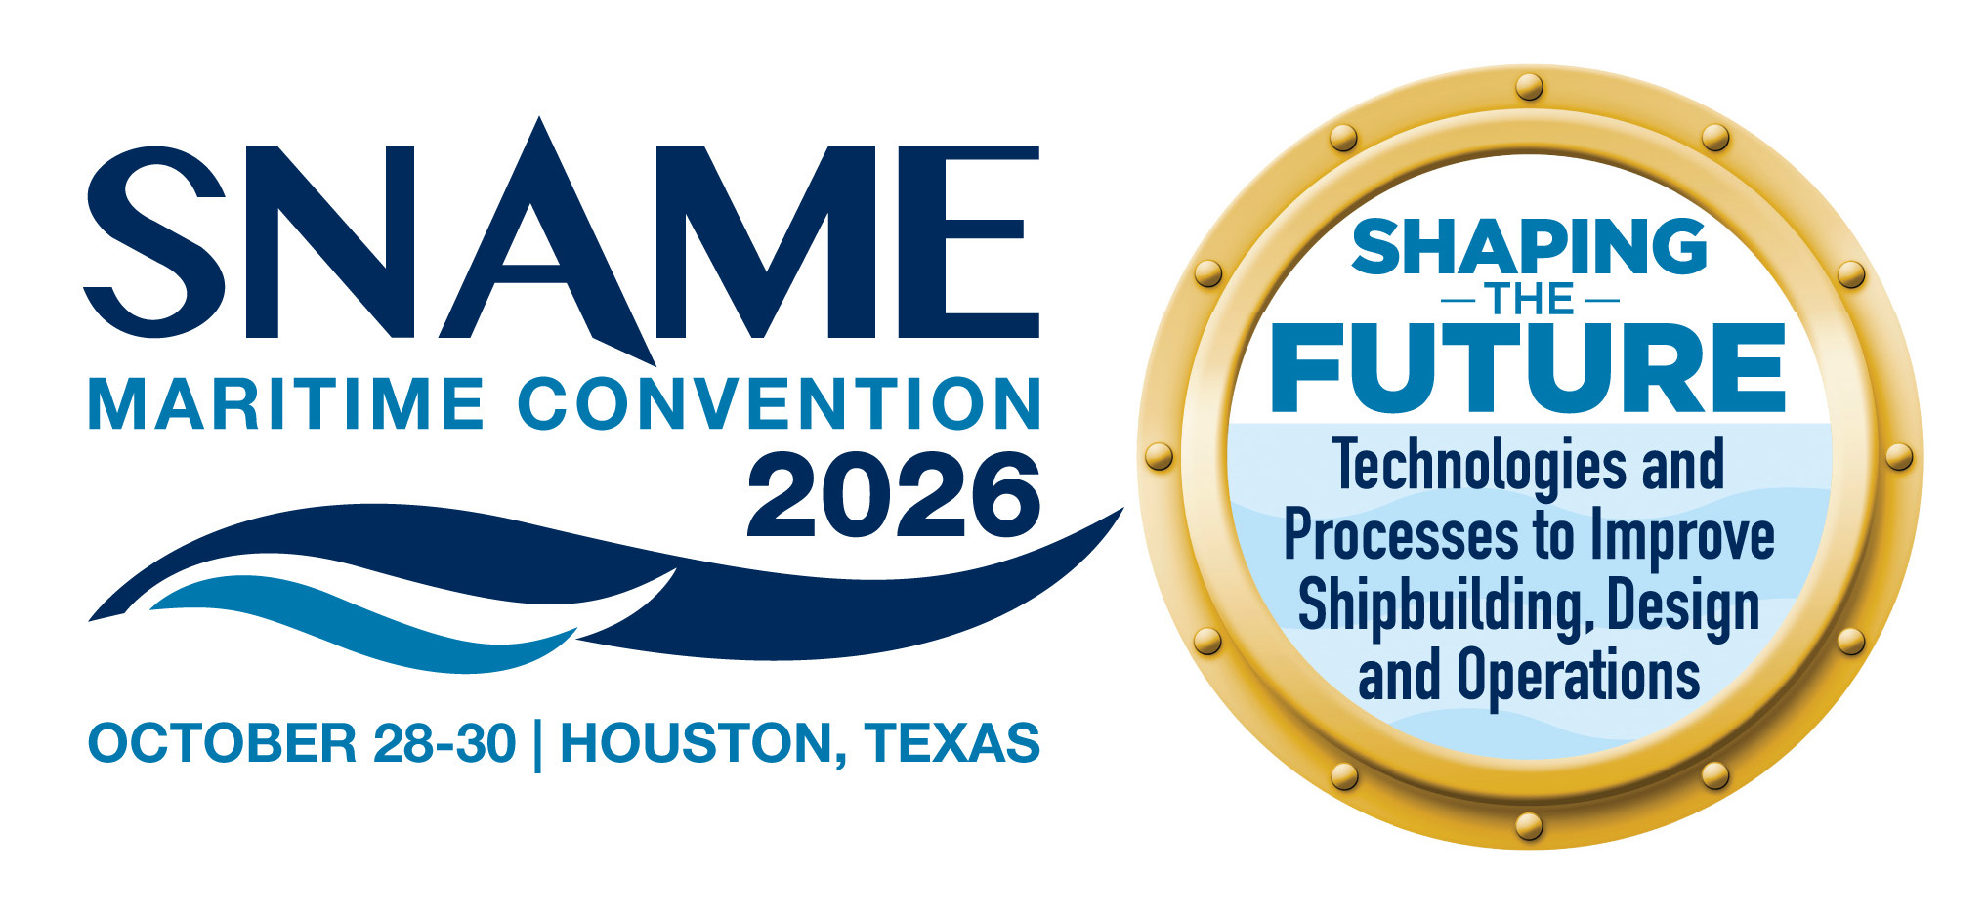
Friday, October 30, 2026
TIME | PROGRAM | Location
7:00 AM – 24 HH | Office | Directors
7:00 AM – 5:00 PM | Registration OPEN | Legends Foyer
7:30 AM – 8:45 AM  (75 Minutes) | Breakfast & Panel | Discovery
7:30 AM – 8:45 AM  (75 Minutes) | PANEL Session 4  The Circular Economy: Asset Transformation and Data Hubs  Speakers:  Moderator: Thalia Kruger  Sponsored by: | Discovery
9:00 AM – 10:00 AM  (60 Minutes) | SNAME Business Session | Discovery
9:00 AM – 2:30 PM | Exhibit Hall Open | Legends Ballroom
10:00 AM – 10:30 AM | Break / Visit Exhibits  Sponsored by: | Legends
10:30 AM – 11:30 AM | Maritime Job Fair Set-up | TBD
10:30 AM – 12:20 PM  (110 Minutes) | PANEL Session 5  Fireside Chat and Maritime-Space Convergence: Engineering the Extreme Frontier  Speakers:  Moderator: Thalia Kruger  Sponsored by: | Discovery
 | TECHNICAL SESSION 7
10:30 AM – 11:20 AM  (50 Minutes) | Tech Session 7A (SMC-098) TRACK: Hydrodynamics  Static vs. Dynamic Bubble Sweepdown CFD Analyses and Model Tests  Speakers: Jordan Castillo; Kris Karri; John Schmidt  Moderator: | Founders I
10:30 AM – 11:20 AM  (50 Minutes) | Tech Session 7B (SMC-034) TRACK: Design  Classification Perspectives on Design, Protection, and Installation of HV Subsea Cables  Speaker: Yogita Akhare; Jude Tomdio; Jin Wang; Michael Kei  Moderator: | Founders II
10:30 AM – 11:20 AM  (50 Minutes) | Tech Session 7C (SMC-XXX) TRACK:  Course Title  Speakers:  Moderator: | Founders III
10:30 AM – 11:20 AM  (50 Minutes) | Tech Session 7D (SMC-077) TRACK: Operations  Present-Day Marine Salvage Revisited: Navigating Evolving Technology and Enduring Principles  Speakers: Matthew Cooke  Moderator: | Founders IV
 | TECHNICAL SESSION 8
11:30 AM – 12:20 PM  (50 Minutes) | Tech Session 8A (SMC-XXX) TRACK:  Course Title  Speakers:  Moderator: | Founders I
11:30 AM – 12:20 PM  (50 Minutes) | Tech Session 8B (SMC-041) TRACK: Design  Seakeeping Optimization of an Offshore Support Vessel Using Parametric Modeling  Speaker: Andreas Arapakopoulos; Michal Orych; Stefan Harries; Simon Hauschulz  Moderator: | Founders II
11:30 AM – 12:20 PM  (50 Minutes) | Tech Session 8C (SMC-029) TRACK: Production  Taking First in Class Electrical Design Through Build  Speakers: Ross Jespersen  Moderator: | Founders III
11:30 AM – 12:20 PM  (50 Minutes) | Tech Session 8D (SMC-006) TRACK: Operations  Method assessing AR impacts on human performance, safety, and situational awareness.  Speakers: Whitney Mantooth; Eric VanDerHorn; Vicente Hernandez; Ferris,  Moderator: | Founders IV
12:20 PM – 1:30 PM | Lunch/Visit Exhibits  Sponsored by: | Legends Ballroom
1:30 PM – 3:20 PM  (110 Minutes) | PANEL Session 6  Design & Emergency Response Considerations for Vessels Using Alternative Fuels  Speakers: CDR Brent Mellen, Jim Elliott, Lawrence Malizzi  Moderator: Melissa L. Hertel  Sponsored by: | Discovery
1:30 PM – 3:20 PM | Maritime Job Fair  Sponsored by: Chevron
 | TECHNICAL SESSION 9
1:30 PM – 2:20 PM  (50 Minutes) | Tech Session 9A (SMC-014) TRACK: AI-Operations  How Marine Robotics have been transforming Vessel and Terminal Inspections  Speakers: Dimitrios Dikos; David Fraser  Moderator: | Founders I
1:30 PM – 2:20 PM  (50 Minutes) | Tech Session 9B (SMC-044) TRACK: Design  Design-Wave Frequency vs Time-Domain Benchmarking for Offshore Wind Turbine Semi-Submersibles  Speaker: Matteo Bucchini; Won Ho Lee; James Craig; Vincent Yuan Sheng Liu; Brennan Armstrong Maybee; Alex Yang  Moderator: | Founders II
1:30 PM – 2:20 PM  (50 Minutes) | Tech Session 9C (SMC-054) TRACK: Production  Simulation-Based Evaluation of Robotic Welding for Optimized Ship Assembly  Speaker: Sufian Imam Wahidi; Selda Oterkus; Oterkus, Erkan; Heri Supomo; Triwilaswandio Wuruk Pribadi; Ocid Mursid  Moderator: | Founders III
1:30 PM – 2:20 PM  (50 Minutes) | Tech Session 9D (SMC-102) TRACK: Operations  OpenDarkSTS: Open-Source Dark Ship-to-Ship Transfers Detector  Speaker: Paul Koola; Pou Hei Chan; Madhulika Dey; Sohail Ansari  Moderator: | Founders IV
 | TECHNICAL SESSION 10
2:30 PM – 3:20 PM  (50 Minutes) | Tech Session 10A (SMC-023) TRACK:  Robust Simulation Framework for Verification and Validation of Marine Autonomous Navigation  Speakers: Nataraj Sudharsan; Anthony Saaiby; Mayur S. Patil; JiaChang Xing; Keliang Pan; Veneela Ammula; Jude Tomdio; Jin Wang; Michael Kei; Prabhakar Pagilla; HeonYong Kang; Sivakumar Rathinam  Moderator: | Founders I
2:30 PM – 3:20 PM  (50 Minutes) | Tech Session 10B (SMC-047) TRACK: Design  Shaping the Future of Survivability: Leveraging VAST for Early-Stage Ship Design Vulnerability Reduction  Speaker: Kelsey Murray Rogers; Robert Meismer  Moderator: | Founders II
2:30 PM – 3:20 PM  (50 Minutes) | Tech Session 10C (SMC-022) TRACK: Production  A Hybrid Physical-Test and Data-Driven Framework for Additive Manufacturing Qualification  Speakers: Dongchun Qiao; Bo Wang; Michael Kei; Marcus Cridland  Moderator: | Founders III
2:30 PM – 3:20 PM  (50 Minutes) | Tech Session 10D (SMC-030) TRACK: Operations  CFD Simulation of Ammonia Gas Dispersion and Its Miigation With Water Curtain Onboard a Vessel  Speakers: Kai Yu  Moderator: | Founders IV
 | TECHNICAL SESSION 11
3:30 PM – 4:20 PM  (50 Minutes) | Tech Session 11A (SMC-XXX) TRACK:  Course Title  Speaker:  Moderator: | Founders I
3:30 PM – 4:20 PM  (50 Minutes) | Tech Session 11B (SMC-XXX) TRACK:  Course Title  Speakers:  Moderator: | Founders II
3:30 PM – 4:20 PM  (50 Minutes) | Tech Session 11C (SMC--094) TRACK: Production  Risk Assessment of American Commercial Shipbuilding  Speakers: Omar Ahmed; Shashwat Tripathi; Erna Grelle; Christopher Kolodziej  Moderator: | Founders III
3:30 PM – 4:20 PM  (50 Minutes) | Tech Session 11D (SMC-XXX) TRACK:  Course Title  Speakers:  Moderator: | Founders IV
 | TECHNICAL SESSION 12
4:40 PM – 5:30 PM  (50 Minutes) | Tech Session 12A (SMC-XXX) TRACK:  Course Title  Speaker:  Moderator: | Founders I
4:40 PM – 5:30 PM  (50 Minutes) | Tech Session 12B (SMC-XXX) TRACK:  Course Title  Speakers:  Moderator: | Founders II
4:40 PM – 5:30 PM  (50 Minutes) | Tech Session 12C (SMC-XXX) TRACK:  Course Title  Speakers:  Moderator: | Founders III
4:40 PM – 5:30 PM  (50 Minutes) | Tech Session 12D (SMC-XXX) TRACK:  Course Title  Speakers:  Moderator: | Founders IV

